Press release | 11 April 2024

The New European Bauhaus Academy (NEBA):
training professionals in circular biobased construction, renovation and urban transformation

Launch of the NEBA Alliance at the NEB Festival in Brussels

The NEB Academy, a flagship initiative of the European Commission, has set out to accelerate the up- and re-skilling of architecture, construction, and engineering (ACE) professionals and adjacent actors. Through a network of training hubs across Europe that bundle regional competencies and facilitate access to contents on sustainability, circularity and bio-based material knowledge. A strong partnership of universities, regional training centres, authorities and EU associations has kicked of the NEBA Alliance to co-create this novel platform for the construction sector.
The urgency of the climate crisis and the construction sector being responsible for more than 40% of GHG emissions requires accelerating the transfer and adoption of climate change mitigation skills and tools to workers, businesses, policy makers, and the public. Therefore, Ursula Von der Leyen, President of the European Commission, announced the NEB Academy in November 2022 as a main flagship of the New European Bauhaus.
The initiative will make training materials easily accessible and offer courses in real-time. They will be delivered through an international network establishing a growing number of Hubs across Europe that have regional coverage and expertise in specific topics. In this way, these tailored programs support the transition from a linear and fossil-based system to a more circular, regenerative and distributive economy designed to thrive within the planetary boundaries.
The NEB Academy aims to raise awareness, improve skills, and encourage commitment among stakeholders to drive change. Enhancing biobased industrialisation and digitalisation in the construction sector, the second largest industrial ecosystem in the EU, will create opportunities to attract young talent and skilled workers, contributing to the growth of the circular bioeconomy and the EU Green Deal. The initiative supports the goal of creating 160,000 additional green jobs in the EU construction sector through the Renovation Wave.
The NEB Academy will establish an open marketplace to match high quality training offers with skills needs and demands of different target groups. Setting up a central portal and database of certified training materials, courses, and modules, along with a selection of best practices in pedagogies it will enable widespread scaling of training on bio-based materials in sustainable construction. The curated NEB Academy course catalogue, validated according to thematic domains and NEB values, will allow trainers and trainees to immediately find the best suited training opportunities.
Quotes
“Providing training for actors all across the construction ecosystem, and spread all around Europe, will help increase the use of biomaterials and ensure more people have access to healthy, beautiful buildings for work, living, and learning.”
Prof. Andreja Kutnar, University of Primorska, Slovenia, Coordinator of NEBA Alliance
“I welcome the New European Bauhaus Academy Alliance, a powerhouse of 14 European partners, ready to launch its EU-wide training network. It will be a solid support for Europe's construction industry, addressing labour shortages and promoting knowledge sharing including on sustainable bio-based solutions, like the circular use of wood and other innovative materials.”
Ursula von der Leyen, President of the European Commission
“The New European Bauhaus is about bringing the European Green Deal to our living spaces. To make it a success, we need to equip our construction sector with the skills and knowledge it needs to tap into the potential of sustainable solutions. This is where the NEB Academy will make a difference.”
Iliana Ivanova, Commissioner for Innovation, Research, Culture, Education and Youth
“I welcome the New European Bauhaus Academy Alliance which, through its diverse expertise across the EU, will address skill gaps in the sustainable and circular construction sector and create better employment opportunities at the regional and national level, while promoting high-quality and inclusiveness in construction.
Elisa Ferreira, Commissioner for Cohesion and Reforms
Source of original EC press release:
https://ec.europa.eu/commission/presscorner/detail/en/ip_23_6593
NEB Festival Forum 2024 – official launch of the NEBA Alliance:
https://new-european-bauhaus.europa.eu/festival/forum_en
Contact
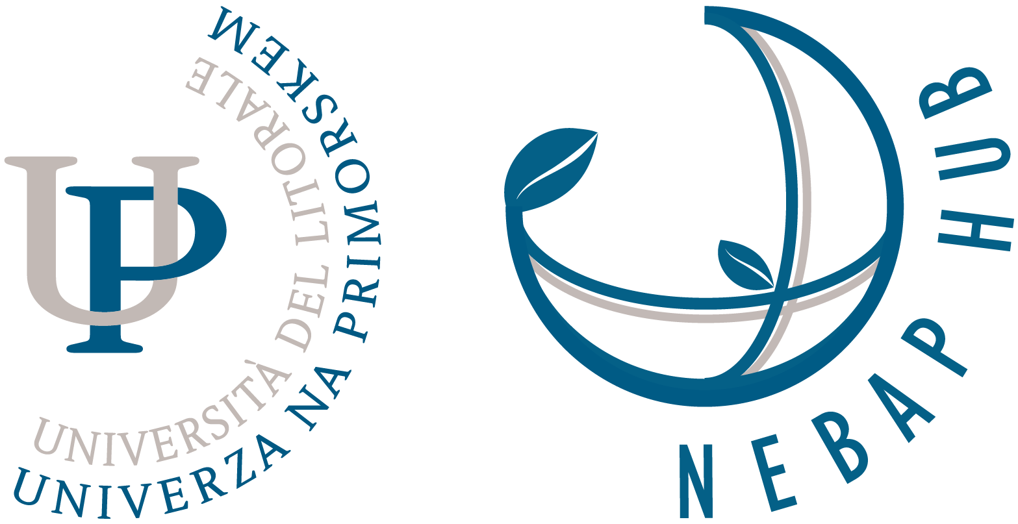 | University of Primorska | NEBAP Hub  Head Office: Titov trg 4, 6000 Koper, Slovenia  Operational Premises: InnoRenew CoE, Livade 6a, 6310 Izola  Head: prof. dr. Andreja Kutnar  T: +386 (0)40 282 944 | E-mail: nebap-hub@upr.si
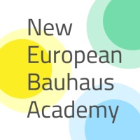 | Follow us on  LinkedIn !  https://bit.ly/nebali | Download the  press release kit:  https://bit.ly/nebapk1
Acknowledgment
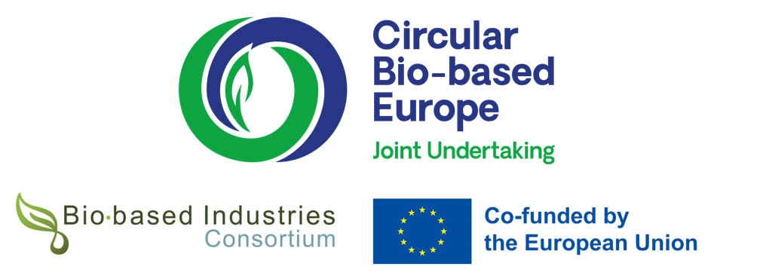
The project is supported by the Circular Bio-based Europe Joint Undertaking and its members
under Horizon Europe grant no. 101160532 | cordis.europa.eu/project/id/101160532

Background information

The NEBA Alliance consortium

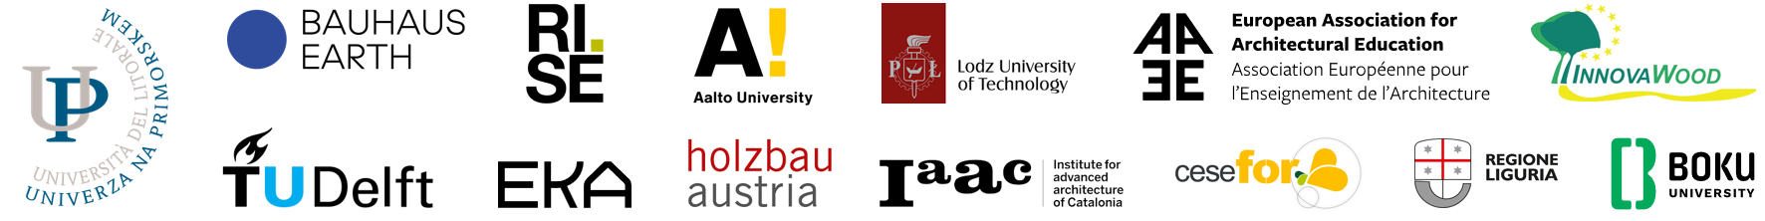
NEBAP Hub: 1. University of Primorska, Slovenia, offers education in sustainable built environments research and education. It hosts the UNESCO Chair for Interpretation and Education for Enhancing Integrated Heritage Approaches and has established the first NEB Academy Pioneer Hub. upr.si
2. Holzbau Austria, the Federation of Austrian Carpenters representing SME-sized crafts enterprises and partner in national and European standardization (Timber Construction Europe). holzbauaustria.at
3. Lodz University of Technology, Poland, is a leading technical university, in a consortium in the field of architectural and urban design, adaptation of historical buildings, urban revitalisation, cultural heritage protection, nature-based solutions in architecture and urban planning, and digital technologies (BIM). p.lodz.pl/en
Nordic Bauhaus Hub: 4. RISE Research Institutes of Sweden is the national institute and innovation partner, operating in transition management, applied research and development, testing, inspection and certification, and lifelong learning. ri.se
5. Aalto University brings together art and science and is a Nordic leader in higher education for design, architecture, art, art education, and media. The renowned Department of Architecture focuses on sustainable construction and is active in multidisciplinary research on living environments. aalto.fi
6. Estonian Academy of Arts is the only public university in Estonia providing higher education in fine arts, design, architecture, media, visual studies, art history, and conservation, and lifelong learning opportunities through the Open Academy. artun.ee
Central Hub: 7. Bauhaus Earth is a Berlin-based think tank, active on global climate impacts of buildings, policy roadmaps for biobased materials, transition management and capacity building programmes for public administrations. bauhauserde.org
8. TU Delft is among the top ranked universities in Europe in civil engineering, architecture, and mechanical engineering. A front runner in online education with over 3.5 million online learners worldwide, it offers 130 MOOCs, 10 online academic courses; 45 professional education courses; 35 short programmes by 400 dedicated instructors. https://online-learning.tudelft.nl
South Hub: 9. IAAC Institute for Advanced Architecture of Catalonia, Spain, is a pioneer in design & urbanism, sustainable construction, material technology, digital fabrication, advanced design computation, ecological design, robotics, hands-on design+build education. iaac.net
10. Regione Liguria is a territorial public institution that engages in intensive capacity building on NEB themes and culture for stakeholders such as municipalities, provinces, park authorities, research bodies, businesses, educational actors, citizens' associations and the tertiary sector. regione.liguria.it
11. CESEFOR Foundation of the Region of Castilla and Léon in Spain promotes the whole forest-based value chain towards sustainability, bioeconomy, and biodiversity conservation. A main priority is upskilling and new employment in wood construction and the habitat sector. cesefor.com
EU Outreach Hub: 12. InnovaWood is the European network for wood research, innovation and education with 70+ member organisations in 30 countries of Europe. IW chairs the Wood4Bauhaus Alliance of five European umbrella organisations in the wood sector. innovawood.com
13. EAAE European Association for Architectural Education is an international organisation of 150+ architectural schools aiming to advance the quality of architectural education and to promote the quality of architecture in Europe. eaae.be
14. BOKU / European Bioeconomy University is a network of eight leading universities in all sectors of the bioeconomy. EBU members share knowledge and educational formats, supporting each other in EU projects under Horizon, Erasmus, Marie Curie-Sklodoswka and other programmes. The BOKU University in Vienna holds the current presidency. european-bioeconomy-university.eu
EC CORDIS page cordis.europa.eu/project/id/101160532

